North-South Network Traffic

🧭 What Is North-South Network Traffic?
# Source: AI Source: Provided by: [Data Path: Persons Table -> ID Column: 1, Name_En Column: Motasem Essam] -> From: [ChatGPT] on [12/9/2025]
North-South traffic refers to network traffic that flows in and out of a data center, enterprise, or internal network — typically between internal resources and external clients or users.

🧠 Simple Definition:
# Source: AI Source: Provided by: [Data Path: Persons Table -> ID Column: 1, Name_En Column: Motasem Essam] -> From: [ChatGPT] on [12/9/2025]
North-South traffic is inbound and outbound traffic that moves between internal systems (like servers) and external sources (like users on the internet).

📡 Examples of North-South Traffic
# Source: AI Source: Provided by: [Data Path: Persons Table -> ID Column: 1, Name_En Column: Motasem Essam] -> From: [ChatGPT] on [12/9/2025]
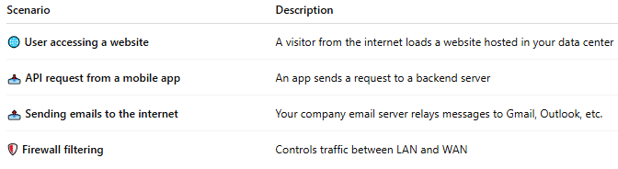
Scenario | Description
🌐 User accessing a website | A visitor from the internet loads a website hosted in your data center
📥 API request from a mobile app | An app sends a request to a backend server
📤 Sending emails to the internet | Your company email server relays messages to Gmail, Outlook, etc.
🛡 Firewall filtering | Controls traffic between LAN and WAN

🧭 Why “North-South”?
# Source: AI Source: Provided by: [Data Path: Persons Table -> ID Column: 1, Name_En Column: Motasem Essam] -> From: [ChatGPT] on [12/9/2025]
In data center diagrams:
- North = External (internet, clients, users)
- South = Internal (servers, databases, apps)
So, North-South represents traffic moving vertically between the inside and outside.

📦 Characteristics of North-South Traffic
# Source: AI Source: Provided by: [Data Path: Persons Table -> ID Column: 1, Name_En Column: Motasem Essam] -> From: [ChatGPT] on [12/9/2025]
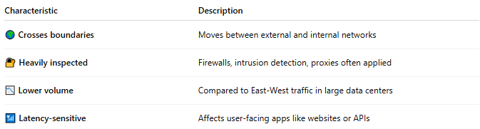
Characteristic | Description
🌍 Crosses boundaries | Moves between external and internal networks
🔐 Heavily inspected | Firewalls, intrusion detection, proxies often applied
📉 Lower volume | Compared to East-West traffic in large data centers
📶 Latency-sensitive | Affects user-facing apps like websites or APIs

🔐 Security Considerations
# Source: AI Source: Provided by: [Data Path: Persons Table -> ID Column: 1, Name_En Column: Motasem Essam] -> From: [ChatGPT] on [12/9/2025]
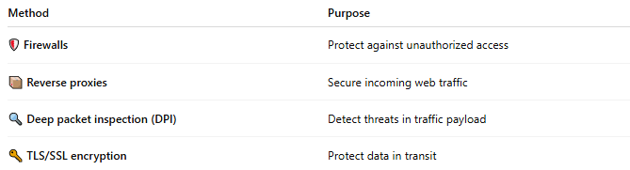
Method | Purpose
🛡 Firewalls | Protect against unauthorized access
📦 Reverse proxies | Secure incoming web traffic
🔍 Deep packet inspection (DPI) | Detect threats in traffic payload
🔑 TLS/SSL encryption | Protect data in transit

🆚 North-South vs East-West Traffic
# Source: AI Source: Provided by: [Data Path: Persons Table -> ID Column: 1, Name_En Column: Motasem Essam] -> From: [ChatGPT] on [12/9/2025]
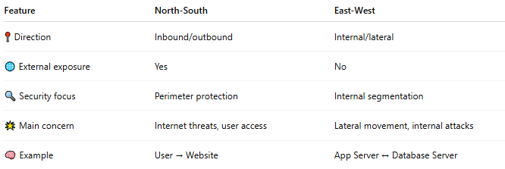
Feature | North-South | East-West
📍 Direction | Inbound/outbound | Internal/lateral
🌐 External exposure | Yes | No
🔍 Security focus | Perimeter protection | Internal segmentation
🌟 Main concern | Internet threats, user access | Lateral movement, internal attacks
🧠 Example | User → Website | App Server ↔ Database Server

📌 Summary
# Source: AI Source: Provided by: [Data Path: Persons Table -> ID Column: 1, Name_En Column: Motasem Essam] -> From: [ChatGPT] on [12/9/2025]
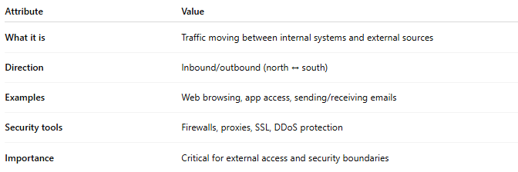
Attribute | Value
What it is | Traffic moving between internal systems and external sources
Direction | Inbound/outbound (north ↔ south)
Examples | Web browsing, app access, sending/receiving emails
Security tools | Firewalls, proxies, SSL, DDoS protection
Importance | Critical for external access and security boundaries

